EXERCISE 2: ERROR HANDLING
Scenario 1: Safe Transfer of Funds
Question:
Write a stored procedure SafeTransferFunds that transfers funds between two accounts. Ensure that if any error occurs (e.g., insufficient funds), an appropriate error message is logged and the transaction is rolled back.
Code
CREATE OR REPLACE PROCEDURE SafeTransferFunds(
p_from NUMBER,
p_to NUMBER,
p_amount NUMBER
)
IS
v_balance NUMBER;
BEGIN
SELECT Balance
INTO v_balance
FROM Accounts
WHERE AccountID = p_from;

IF v_balance < p_amount THEN
RAISE_APPLICATION_ERROR(-20001,'Insufficient Funds');
END IF;

UPDATE Accounts
SET Balance = Balance - p_amount
WHERE AccountID = p_from;

UPDATE Accounts
SET Balance = Balance + p_amount
WHERE AccountID = p_to;

COMMIT;

EXCEPTION
WHEN OTHERS THEN
ROLLBACK;
DBMS_OUTPUT.PUT_LINE(SQLERRM);
END;
/

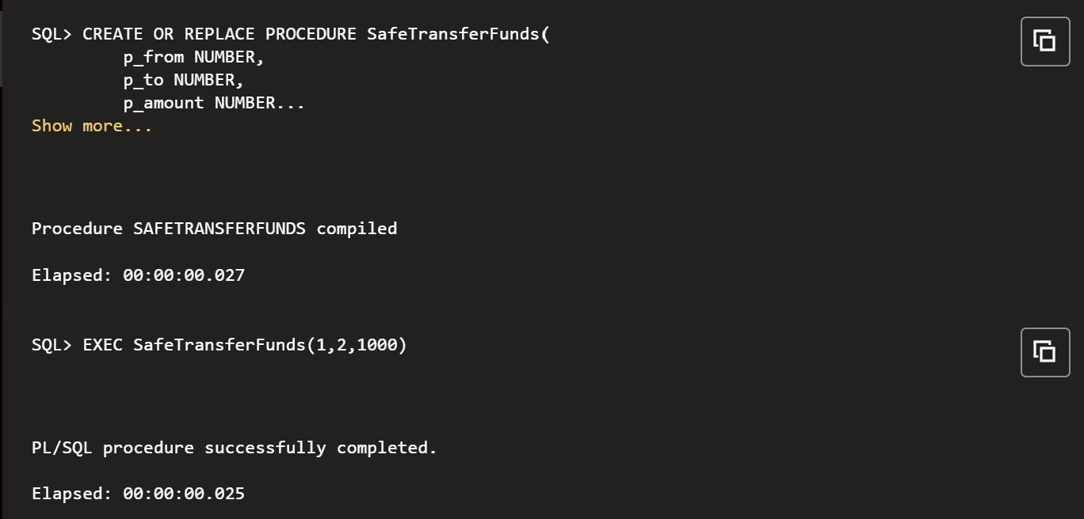

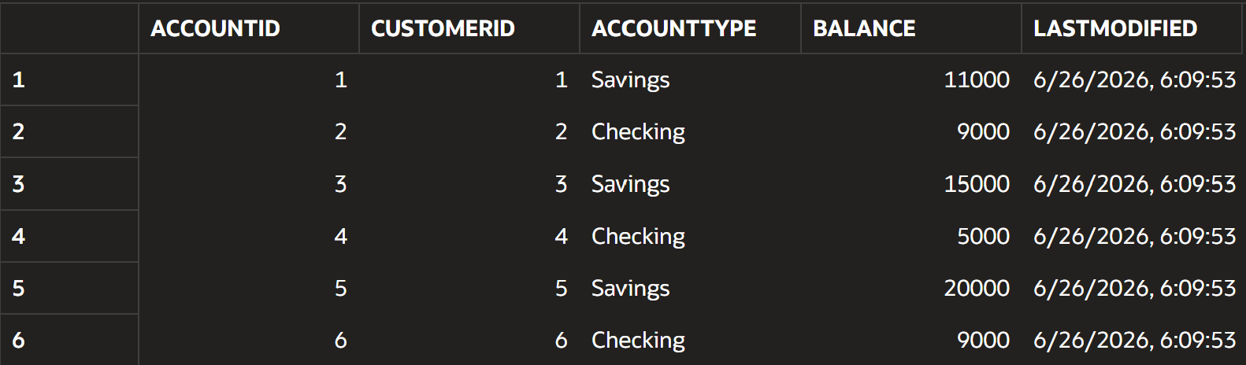

Scenario 2: Update Employee Salary
Question:
Write a stored procedure UpdateSalary that increases the salary of an employee by a given percentage. If the employee ID does not exist, handle the exception and log an error message.
Code
CREATE OR REPLACE PROCEDURE UpdateSalary(
p_empid NUMBER,
p_percent NUMBER
)
IS
BEGIN
UPDATE Employees
SET Salary = Salary + (Salary * p_percent / 100)
WHERE EmployeeID = p_empid;

IF SQL%ROWCOUNT = 0 THEN
RAISE NO_DATA_FOUND;
END IF;

COMMIT;

EXCEPTION
WHEN NO_DATA_FOUND THEN
DBMS_OUTPUT.PUT_LINE('Employee ID does not exist.');
END;
/
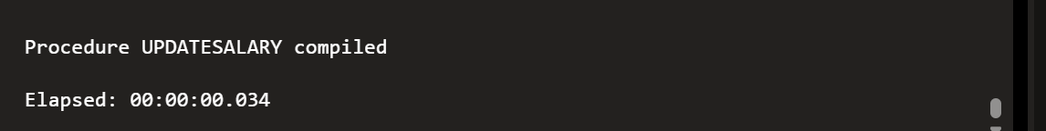
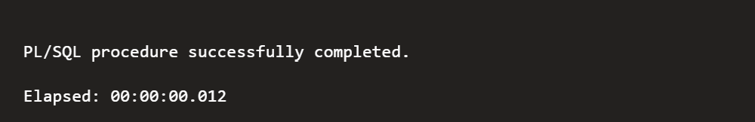
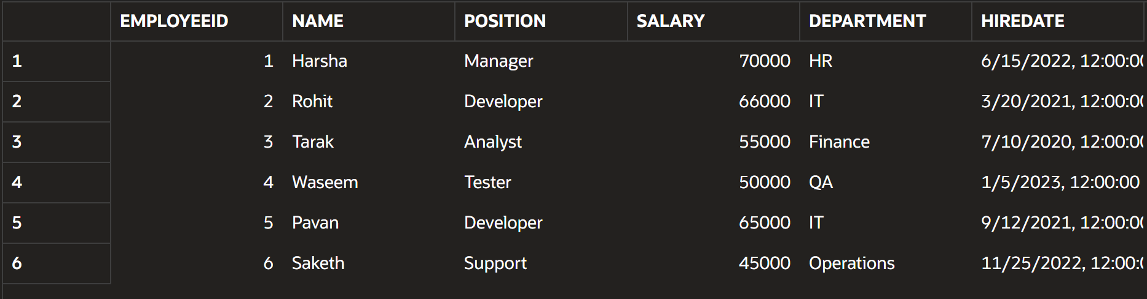

Scenario 3: Add New Customer
Question:
Write a stored procedure AddNewCustomer that inserts a new customer into the Customers table. If a customer with the same ID already exists, handle the exception by logging an error and preventing the insertion.
Code
CREATE OR REPLACE PROCEDURE AddNewCustomer(
p_id NUMBER,
p_name VARCHAR2,
p_dob DATE,
p_balance NUMBER
)
IS
BEGIN
INSERT INTO Customers(
CustomerID,
Name,
DOB,
Balance,
LastModified,
IsVIP
)
VALUES(
p_id,
p_name,
p_dob,
p_balance,
SYSDATE,
NULL
);

COMMIT;

EXCEPTION
WHEN DUP_VAL_ON_INDEX THEN
DBMS_OUTPUT.PUT_LINE('Customer ID already exists.');
END;
/
